**Reduced Row Echelon Form (ייצוג מטריצה מדורגת מצומצמת)**

**Instructions:**

-This method returns a matrix that is the reduced row echelon form of the original matrix. Note that the original matrix must remain unchanged.

-To find the reduced row echelon form of a matrix, we conduct Gaussian elimination on the matrix to achieve a matrix as follows:

**1.** For each row (that is non-zero), the leading non-zero digit is 1.

**2.** For each leading digit 1, all cells of the matrix in the same column are zeroes.

**3.** The leading digit 1 of every non-zero row is to the right of the leading digit 1 of every row above it.

**4.** All rows of only zeroes are found at the bottom of the matrix.

-For example:

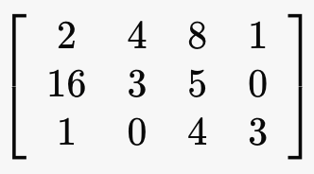 becomes 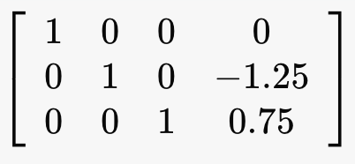

(Original Matrix) (Reduced Row Echelon Form matrix)

-For further reading and for testing see the following links:

**RREF Matrix calculator:**

<https://www.emathhelp.net/calculators/linear-algebra/reduced-row-echelon-form-rref-calculator/?i=%5B%5B2%2C4%2C8%2C1%5D%2C%5B16%2C3%2C5%2C0%5D%2C%5B1%2C0%2C4%2C3%5D%5D&reduced=on>

**Wikipedia Reference:**

<https://en.wikipedia.org/wiki/Row_echelon_form#Reduced_row_echelon_form>

**Tip:**

-split up each of the Gaussian Elimination operations (row switch, multiplication by scalar, row subtraction, etc.) each into their own functions. This will make it much easier to debug.

**Note:**

-These functions should be implemented in one of the .cpp files in your project, not in the header files.